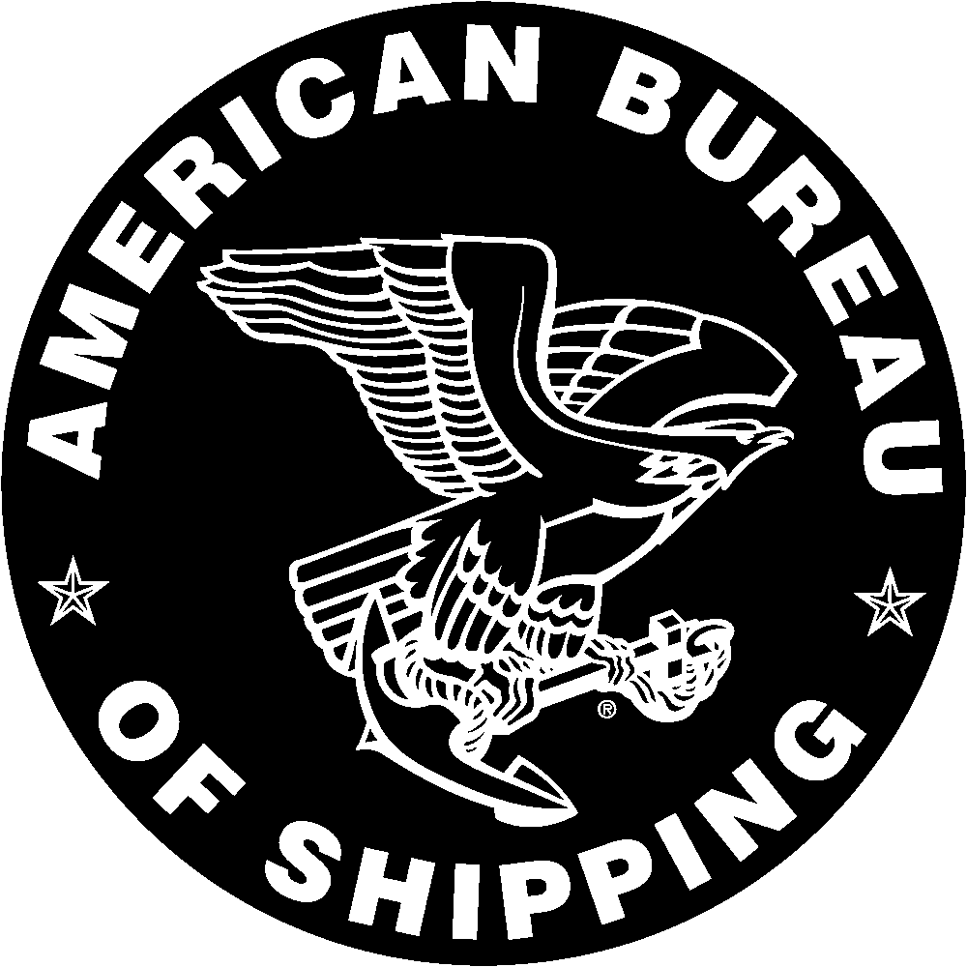 | American Bureau of Shipping  APPLICATION FOR CERTIFICATION OF  CONTAINER CORNER CASTINGS

I, the undersigned, apply for the certification of Container Corner Castings to be built in conformance with the American Bureau of Shipping Rules for the Certification of Cargo Containers.

This is to confirm that the corner castings described on this form will be manufactured and tested under a quality control program approved by the American Bureau of Shipping and that they will be available for inspection during manufacture.

General Arrangement
Drawing Number

Model
Number

Identification
Markings

Weight of
Casting

Heat Treatment
Condition Normalized Annealed Normalized and Tempered

Material
Specification

Chemical  Composition  Mechanical*  Properties | C  Tensile | Mn  Yield | Si  Elongation | S  Reduction  Of Area | P  Charpy
*Identify Units

Nondestructive Testing Process/Percentage of Casting Examined

Radiography % Ultrasonic % Dye Penetrant %

Magentic Particle %
Other (specify) %

This is to further confirm that I will furnish the American Bureau of Shipping the necessary drawings and specifications required for review, prior to manufacture, and that changes in design or materials will not be made without first receiving written approval from the American Bureau of Shipping.

Note: For additional orders to an approved design complete the lower portion of this form only.

Number of Sets New Design Re-Order Model

Manufacture/Address

Name/Title

Signature Date

NOTE: This application is subject to the standard Terms and Conditions contained in the American Bureau of Shipping’s “Survey, Report or Other Service Purchase order.”

